Cell Engineering - Exercise Session 1

Please note that this exercise session is graded, and that each student will have to submit an individual report.

The Tango-GEMS system
We described in class the TANGO and the GEMS systems (see image below), each with its unique advantages and drawbacks. While TANGO is limited to natural input ligands but can have an arbitrary output, GEMS can sense “non-native” ligands but its output is limited to intracellular signaling domains that activate through dimerization.

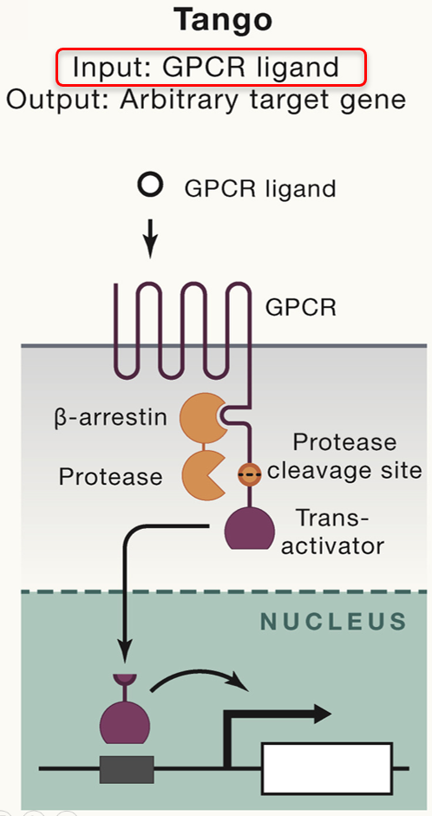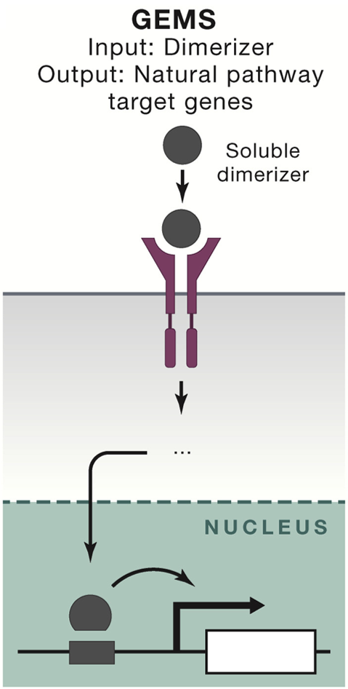

Question 1a) Could you think of a more advanced sensor system that combines the strength of both TANGO and GEMS? Discuss the advantages of your advanced sensor system compared to the drawbacks of the regulatory mechanisms governing TANGO, GEMS. Please provide a clearly labeled schematic drawing of your advanced sensor system and explain your design.

Question 1b) Discuss one potential application where the combined capabilities of your advanced sensor system could be particularly advantageous.

Question 1c) You notice that your “advanced sensor system” shows high basal activity even in absence of your input molecule. Name one potential reason for this.

SOLUTIONS

Question 1:
1a) A more advanced sensor would combine the arbitrary input strategy of GEMS with the arbitrary output strategy of TANGO: Arbitrary ligand mediated dimerization of a receptor heterodimer where each subunit is fused to a protease or a protease cleavage site and transcription factor. Ligand-induced heterodimerization leads to release and nuclear relocation of the transactivator for gene expression.

GEMS vs TANGO:
- GEMS: arbitrary input (including non-natural ligands) sensing capabilities but output is limited to a few natural signaling pathways
- TANGO: limited input (GPCR ligand) sensing capabilities but arbitrary output signaling capabilities (defined by transcription factor)
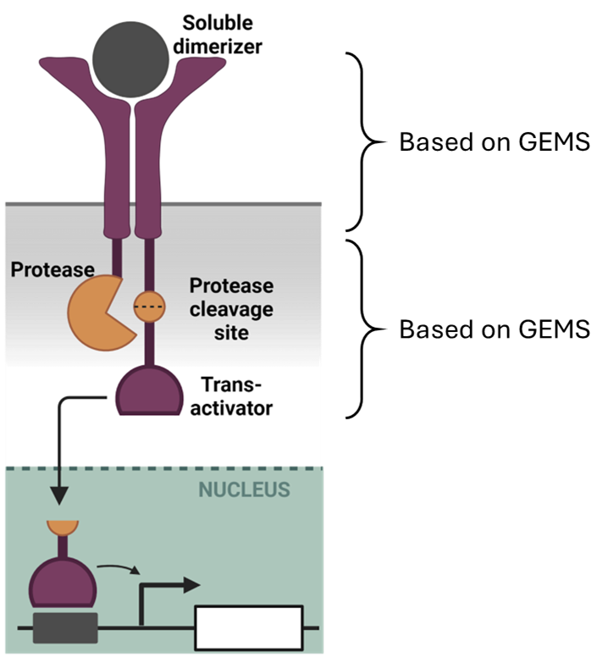

Notes regarding biosensor schematic: it needs to be clear that the protease and the protease cleavage site - transactivator are on two separate protomers.

1b) There are many possible applications where the combined capabilities of the advanced sensor system could be particularly advantageous… one idea could be to build a cell-based biosensor that senses a biomarker (i.e. growth hormone → a non-GPCR ligand) in a sample and results in the expression of a fluorescent reporter.

1c) Basal activity occurs when a receptor is (partially) signalling even in absence of any ligand. The reasons for this will depend on the receptor and it’s activation mechanism, in our case high basal activity could come from ligand-independent dimerization of the receptor, resulting in protease cleavage. Alternatively, there may be another (soluble) protease present in the cell that can cleave the protease cleavage site

